Uncivil citizens. Security, urban policy and the defining up of deviant behavior in Barcelona

Gemma Galdon Clavell

Abstract
On December 23, 2005, Barcelona passed an ‘Ordinance to promote and guarantee peaceful coexistence in the city of Barcelona’ thus putting an end to 5 months of a political race against the clock. In that time frame, incivility had made it to the government’s political agenda and the proposal had been drawn up, discussed, amended and finally passed, generating a heated political debate, capturing the attention of the media and articulating a change of course in the Socialist government’s approach to poverty and social conflict. Even though concerns about civility are nothing new, developments in the last 30 years show there is much to be said about the way societies are regulating and negotiating what is and what is not proper behavior in urban, public space. This paper traces back the political and policy process of the Barcelona Ordinance in the context of recent literature on the subject, looking at the process by which civility and incivility have been defined in this particular local context, the interaction between the actors involved and the political aspects of the process. It ends by highlighting the need to embed local urban studies in a comparative, global analysis, in order to make sense of the local impact of a global security agenda that, while implemented at the local level, seems to be designed through a complex but very effective process of international policy transfer.

Keywords
Civility, deviance, policy process, participation

1. Introduction

- Introduction

On December 23, 2005, Barcelona passed a ‘Civility Ordinance’. The text, approved with the support of the ruling Socialists (PSC), the Left-wing Nationalists (ERC) and the Conservative Nationalists (CiU), the abstention of the Conservatives (PP) and the rejection of the Former Communists (ICV), put an end to a political race against the clock which resulted in a controversial bylaw aimed at “preserving public space as a place for coexistence and civility, where all people can freely develop activities related to their free movement, leisure, meeting and play with full respect for the dignity and rights of others and for the plurality of expressions and ways of living existing in Barcelona”. Since then, similar regulations have proliferated across Spain.

The rushed entrance in the local political agenda of the idea of civility is not an isolated event. The so-called civility bylaws or anti-social behavior orders –civil regulations that establish fines and sanctions for people engaging in “improper behavior” as defined by public authorities and implemented by the Police- have been proliferating in the Western world since the late 90s (Van Brunschot, 2007; European Commission, 1998). Albeit different in each country (even between cities in the same region), these regulations articulate a relationship between civil society and the state that is negotiated in public space. Therefore, they are a constituting part of the Urban Regime (Stone 1989) that is emerging in the 21st Century, and their study can provide new ways of understanding and explaining these new articulations.

But while such policies have been extensively researched in the UK, mainly in the context of exposing New Labour’s changing approach to crime (Fairclough 2000, Matthews and Young 2003), as part of the link between community safety and urban regeneration (Raco 2007) or embedding them in a global process of branding and marketing cities (Davis, 2003; Harvey, 2001; Smith, 1996; Sassen 2001), the extent to which this is indeed a “new” approach or how deviant behavior in cities might be articulating new alliances, policy arenas and Urban Regimes beyond the Anglo-Saxon reality is still under-researched.

The aim of this paper is to present a case study of the ‘Civility ordinance’ passed in Barcelona in late 2005, reviewing the political and policy process that led to the articulation of a security understanding of civility and the creation of a disciplinary tool to address uncivil behavior. The following pages retrace the political narrative that emerged in the months leading up to the final passing of the bylaw in order to lay out the different roles that the city’s political representatives, civil society and corporate actors and the media played once the issue burst into the public, political and institutional spheres, framing the debate about insecurity against a backdrop of social anxieties, migration, globalization and fear.

The goal is to explain the policy process at the local level, rendering explicit the interactions between those actors and the contextual variables, and to explain the impact of the policy process on the final policy outcome (Lasswell, 1996; Ismaili, 2006, Hill, 2005). This approach should both give context to the political process in the city of Barcelona and, at the same time, provide a new narrative that contributes to the understanding of what the current drive to control behavior and redefine deviance tells us about urban policy, governance and politics.

2. Methodoogy

In order to trace back the policy process of Barcelona's Civility Ordinance, 14 people were approached and semi-structured interviews were conducted. Not all interviewees were part of the initial list of actors, and the relevance of some of them only became apparent after their names came up repeatedly while interviewing other subjects. Most actors interviewed hold or held positions of responsibility in the City Council while the text was being drafted, debated and approved. Others took part in the public debate that evolved in the press, alongside the policy process. While their names have been omitted, their posts and responsibilities are mentioned.

The existence of a complete, 1,683-page Administrative file on the policy process, as well as four 700-page volumes of background information at the Barcelona City Hall made the field work a lot easier, and was of invaluable help every time the bureaucratic process would cease to make sense to the unaccustomed eye. In and of themselves, however, the documents were often incapable of capturing the political intrigues and contextual factors that accompanied the Ordinance in its definition process. The media, and especially the printed press, was also key in order to trace the policy process to the months and years before the Ordinance became a policy alternative. The interaction between the actors, the media and the documents, therefore, has proven to be the key factor in the successful retracing of the process that led to the passing of the Ordinance.

3. Defining deviant behavior in the 21st Century

All societies have been compelled to find ways to normalize behavior and define that which is acceptable and unacceptable, proper or improper. But while a tough stance on deviance characterized pre-Modern and early Modern societies, the 20th Century seemed proud to have overcome earlier authoritarian, racist and inegalitarian approaches in favor of a liberal egalitarianism that would eventually give rise to the Welfare State.

Today, however, the once-civilizing nature of urban life seems to have mutated into a situation in which difference and diversity “are viewed as threatening rather than enriching” (Fyfe et al. 2006). And, in a context of falling rates of crime and objective insecurity, moral panics, middle class indignation, and a new-found concern with improper and deviant behavior is making its way to the institutional agenda and instituting policy change. We can try to understand this process in light of different phenomena affecting urban policy in the 21st Century. Our contention, however, is that there has not yet been enough comparative research on this development, and therefore we lack a deep understanding of the continuities and discontinuities that the new bylaws and ordinances to regulate behavior in urban public space articulate, and what they tell us about current developments in urban policy (and, to a certain extent, the future of democratic societies).

Maybe the different labels and concrete definitions that these policies have adopted in different countries is not helping: in Spain, ‘Civility ordinances’ are locally defined and implemented, and include a broad range of activities (some illegal, like unauthorized street selling; some ‘allegal’, like prostitution; and some are merely former nuisances, like skating, playing games and graffiti). In the UK, ‘Anti-social Behavior Orders’ emerged as part of New Labor’s Respect agenda, in order to “bring back a proper sense of respect in our schools, in our communities, in our towns and our villages” by giving more powers to the Police and local communities to deal with nuisance behavior or low-level criminality. In Italy, it is “civil coexistence” and “urban decorum” that is guiding the local ordinances to regulate behavior, while in France the main idea behind this new offensive against improper behavior is that of the “public peace”.

What is interesting is that even though each national process has advanced at its own time and following its own political agendas and windows of opportunity, there is clear convergence stream emerging: a process of what Mooney and Young (2006) have called “defining deviancy up”. In 1993, US Senator Daniel Patick Moynihan said in an article that deviancy was on the increase because there had been a process of “defining deviancy down” in the 70s and 80s, by which “society had been redefining deviancy to exempt much conduct previously stigmatized and accepting as normal behavior considered abnormal by earlier standards”. Mooney and Young (2006) use the same alliteration to describe what has been happening in the UK and the US in the last few years, but turning it on its head and thus arguing that, with falling rates of crime since the mid-90s, what we are living is a process of “defining deviancy up” and lessening tolerance.

Whether we agree with this logic or prefer to adhere to or complement it with other potential explanations, such as what some have seen as an increasing reliance on punitive populism (Wacquant 1999), the “control society” Garland (2001) so eloquently described, the social and political consequences of “liquid modernity” (Bauman 2000) or Beck's (1992) “risk society”, it is clear that bad, anti-social or uncivil behavior has made it to the institutional agenda and articulated policy change in several Western countries in a way that breaks with most of the security policy dynamics that characterized the mid- and second half of the 20th Century.

What follows is a close look at the political process of Barcelona's Civility Ordinance, in order to contribute to a broader reflection on what local processes can tells us about the motives, logic and politics of this generalized crack-down on deviant behavior in public space.

4. Civility: the birth of a word

In April 1998, Spanish philosopher Victòria Camps and Salvador Giner, a sociologist, published the book Civility: A Users’ Manual. It called for a notion of “civility” based on and understood as a “secular ethics” to articulate a new social contract that could surpass national, religious and cultural identities and affiliations. For the authors, civility was the basis of the possibility of “peaceful coexistence”, it stood for the mutual recognition of shared rights and duties and it made it possible to overcome what the authors described as an attitude of animosity towards “intolerant doctrines and dogmas” that could lead to a situation where everything is justified (or defined down) as a consequence of the rejection of a not-so-distant dictatorial past.

However, while between 1997 and 2000 the references to the term “civility” increased in mainstream media, and civility did become a bit of a political tool, it was generally used in positive terms and as a model of behavior, both in news pieces and op-ed articles, as if the idea of civility could become the spearhead of a project designed to overcome the anti-authoritarian attitudes inherited from the anti-Francoist struggle and establish the new customs and values of the Democratic public space. After three years of having some prominence, however, the new-found term started to disappear from the public sphere, as shown by the results of searching for the words “civility” or “incivility” in La Vanguardia, the best-selling regional daily (Figure 1).

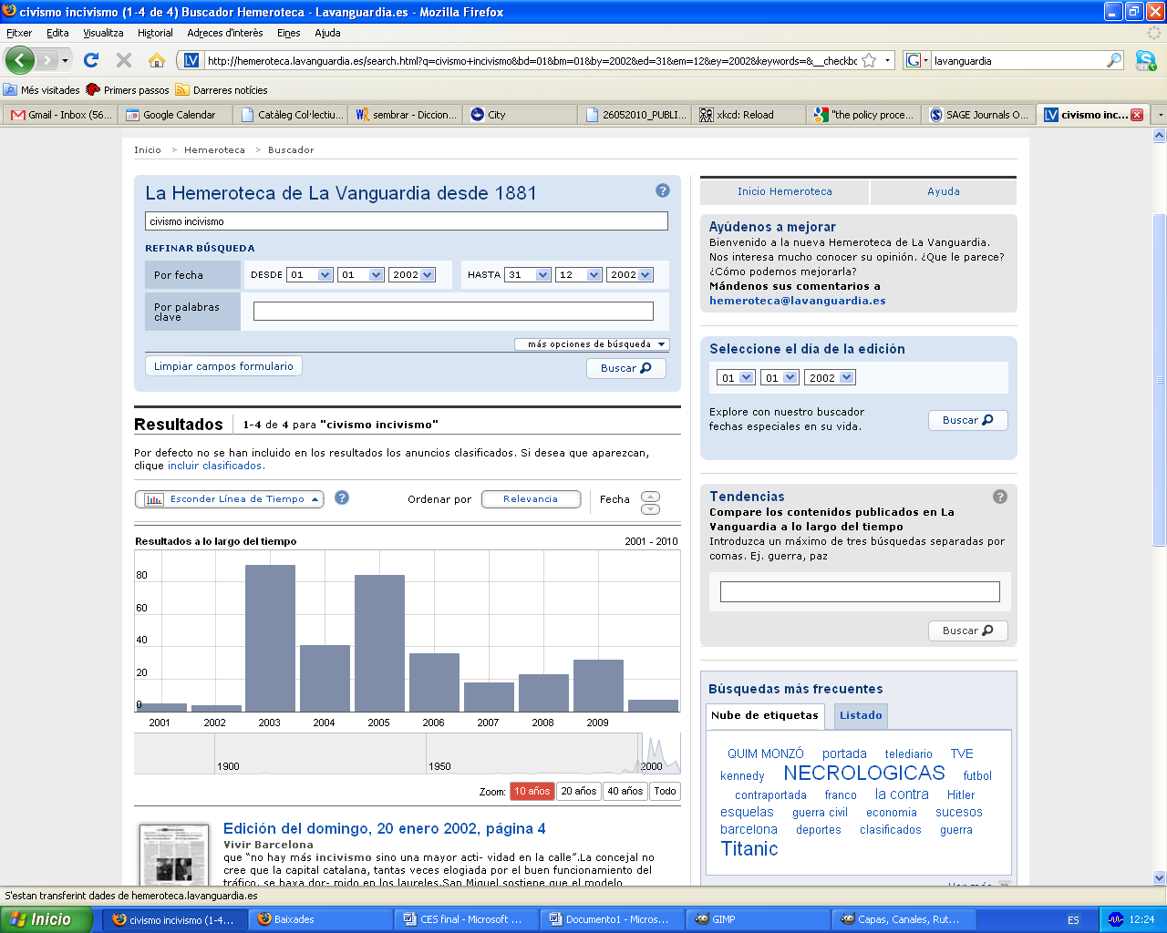
Figure 1. Results for “civismo OR incivismo” on La Vanguardia's search engine.

But this changed on June 23rd, 2003. Just one month before, the Socialists had managed to stay in power after winning the local elections, but their candidate, Joan Clos, had lost more than 60,000 votes and his party had been forced to enter a coalition government with the Left Nationalists (ERC) and the former Communists (ICV), which had doubled their electoral support. The Conservative Nationalists (CiU) had managed to keep their electoral base and the Conservatives (PP) had seen their support increase enough to get in one more representative. The truth is that while it is possible that some of the actors involved only started to feel the media pressure in late June, incivility -and not civility- had been front-page news for weeks already.

In fact, it was the Socialists themselves who rushed to start the new term with a study on civility across Europe and appointed the City Councilor for Culture, Education and Social Services to head a team of experts on the subject. This willingness was further refined in September, when a Plan to promote civility was drawn up, inspired by the analysis put forward by Camps and Giner in 1998, and which became the cornerstone of a program organized around three lines -raising awareness, reinforcing authority and service adjustment (Slide 1)- and several phases to tackle different problems related to street cleanliness, the shared public spaces and animals, noise and mobility (Slides 2, 3).

Slide 1. Diputación de Barcelona: “Metodologías de fomento del civismo. El caso de Barcelona” (2006). Powerpoint presentation.

Slides 2 and 3. Diputación de Barcelona: “Metodologías de fomento del civismo. El caso de Barcelona” (2006). Powerpoint presentation.

The plan was to be run by a Permanent Commission which would meet every month and that started to work very quickly, commissioning awareness raising campaigns (through leaflets and ads in the radio, printed press and television), launching a reflection process organized around a series of conferences and public lectures, getting together well-known people from the Arts, Culture, Sports scene and civil society in a Comissió de Notables, promoting civility plans in the city's districts through small grants, and establishing evaluation mechanisms to monitor several civility indicators. As for the service adjustment, though a close collaboration with the Regidoría de Vía Pública and the Dirección de Inspecciones, several initiatives to improve the quality of public space were launched, such us a greater emphasis on regulating scaffoldings, improving mobility for people with disabilities, eliminating posts from sidewalks, regulating commercial terraces, eliminating ads from the restaurant's chairs, cleaning façades, etc. The goal was to show an increased civility on the part of the Town Hall, which would put it in a better position to demand civility from everyone else.

In this initial phase, civility was understood as a value very much linked to day-to-day activities, and a certain “politeness” in relation to others and to the built environment -what Boyd (2006) calls a “proximate” definition of civility. How the ability to change certain attitudes was to articulate the social change Camps and Giner envisaged was never really explored, though, and while the indicators showed a slight improvement in terms of the amount of litter in the street, for instance, there was a growing feeling that the improvement of citizen's perception of the level of civility in the city was not managing to change the way people behaved in public space. Moreover, some sectors of the city government, less benevolent with Subirats' achievements, begun to express the feeling that the emphasis on the educational dimension of civility had only managed to eclipse the true Republican values of citizenship, thus emptying and marring the term, and condemning it to irrelevance.

Be that the case or not, the documents and reports generated by the Plan para la promoción del civismo show that the commitment to emphasize those aspects of civility linked to awareness raising and inspection did very little, if anything, to tackle the municipal “impotence” and lack of authority condemned by the opposition and recognized by the local government, which was due, according to the Mayor itself, to the absence of sufficient “instrumentos jurídicos” to combat incivility.

Notwithstanding the internal and external criticism, however, between 2003 and 2005 the Socialists continued to emphasize their refusal to pass a new bylaw, and openly declared their preference for a solution involving a simplification of existing local ordinances, a reliance on the impact of the full deployment of the recently-created Regional Police in the city and, above all, the development of a Carta Municipal that would give the Local Police more powers to fight petty crime and more competences to develop a community justice system.

But, as the above-mentioned electoral results render evident, the three-party alliance that allowed the Socialists to keep the Town Hall was born weak, and having to wear the weight of a 25% decrease in the Socialists’ electoral support proved difficult. By May 2005, the Mayor was at the equator of his term, and dragging out two major political crisis: on the one hand, the failure of a Fòrum de les Cultures, an attempt to regain popularity through the organizing of a big event (trying to emulate the success of the Olympic Games in 1992) which had not convinced anyone and had worsened the perception of an increasing gap between citizens and their political representatives. On the other, the recent collapse of a whole building in the Carmel neighborhood due to the public works to build a new metro line, which had resulted in 200 families needing relocation. Both events were taking a toll on the Socialist leadership and the Mayor in particular. There was an attempt to find a new political register that would allow him to get on the offensive by trying to be, for a short period of time, the “people’s Mayor”. But this was not the best time to put the Town Hall’s popularity to the test, and the idea never really took off.

There was a Plan C, however, the Security Card: articulating a Giuliani-inspired proposal to tackle crime, incivility and insecurity; leaving behind awareness-raising and embracing authority and Law and Order. The Town Hall's Securidad Councilor, Jordi Hereu, the Councilor for Participación y Cooperación, Assumpta Escarp, and Rafael Jiménez, a Constitutional Law Professor and then head of the Dirección de Servicios Jurídicos in the Town Hall were asked by the Mayor to work on this Plan C -and, more precisely, on a new Civility Ordinance- before the summer of 2005, even if publicly the discourse was still emphasizing the need to go beyond a Police-led response to incivility.

This was the situation just before the summer of 2005: the Cabinet’s approval ratings were at an all-time low due to the Fòrum de les Cultures and the Carmel collapse; the Mayor had been losing allies both inside and outside the Council’s walls and had chosen to give in the opposition’s pressure and take out the security and authority card; and the voices critical of the awareness-raising approach as a way to tackle deviance and improper behavior in public space were on the rise. At this point, little was left of the definition of civility laid out in the 90s, initially presented and understood as a soft alternative to the security card. The Socialists' insistence on the need for alternatives to Law and Order was to last only for a few more weeks.

5. The long summer of 2005

The specter of incivility had been haunting the city since earlier on in the year. A quick search for the combination of the words “incivismo” and “fiestas” in the search engine of La Vanguardia, provides indisputable proof of a change in the making: in 2002, the combination of the two terms provided two matches; in 2005, 79 –forty times more than three years earlier, and 150% more than in the year before (Figure 2). In most cases, the anticipation of trouble was linked to the summer months and the celebration of the annual neighborhood festivals (“Festes”) in Gràcia and Sants, held in mid and late August, respectively, or the perceived disorder of Barcelona's city center, which was traditionally over-reported by the media during the summer months.

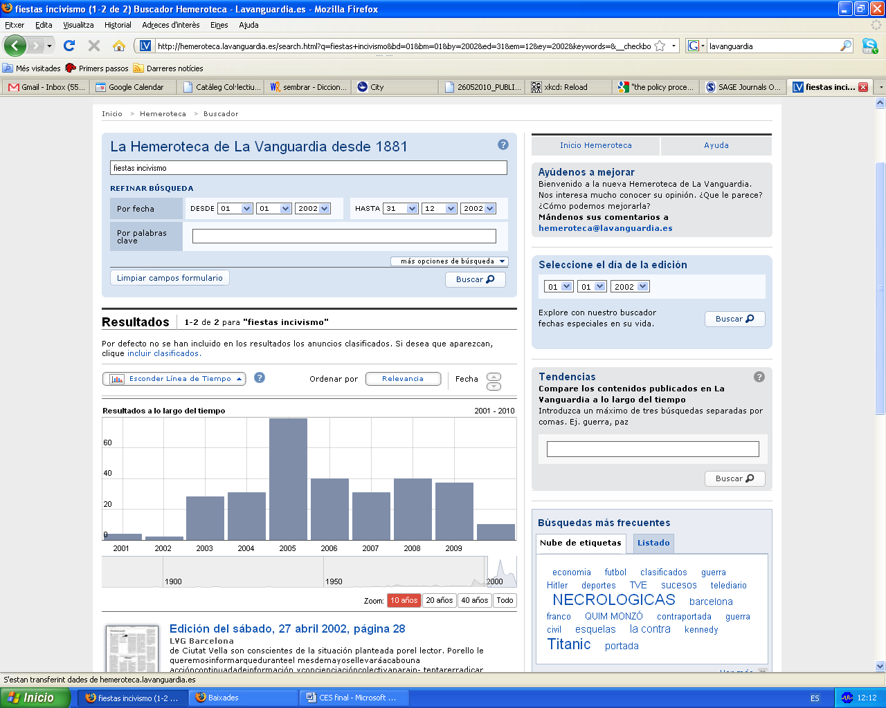
Figure 2. Results for “incivismo+fiestas” on La Vanguardia's search engine.

In a context of media anticipation, the clash between the police and those taking part in the “alternative” Festa de Gràcia on August 16, 2005, which resulted in three people with slight injuries and damages to urban furniture, acted as a self-fulfilling prophecy and encouraged those who had been demanding that the Socialist local government (PSC) adopted a tough Law-and-Order approach a new-found legitimacy. “Firmeza 10: más Guardia urbana y más ordenanzas”, demanded the local candidate for the Conservatives (PP), “contra los gamberros”.

On August 24th, a local government up against the ropes by the media pressure, the political opposition and the growing sense of moral panic held a press conference, without the Mayor, to announce a “modificación de las ordenanzas sobre el uso de la vía pública” in order to establish fines for those activities that were not serious enough to be considered “ni delito ni falta”, but which were understood to disturb the city’s peace. However, the Town Hall representatives continued to stress how theirs was not a commitment to a Law and Order understanding of community safety and security, accused the opposition of having a “visión catastrofista” of the situation, and made a point of differentiating between the clashes in Gràcia and the “incivility” problems in the city center. Moreover, they rejected the proposal made by the Conservatives (PP) and the Catalan Nationalists (CiU) in the opposition to call an extraordinary meeting of the local government.

This approach was still in tune with the Socialist government's policy between 2003 and 2005, a period when, after making civility one of their main objectives and a key part of their political program, they openly declared their preference for a solution to the perceived urban and neighborhood disorder based on raising awareness, improving the efficiency of the municipal services that had an impact on the condition of the physical environment and relying on existing local ordinances. The idea guiding the government's action in those initial months was to tackle the perceived break-down of social ties and cohesion by using “civility” as a tool to promote a collective reflection on the situation, and by designing policies oriented towards popular education.

A few days after the press conference, however, new clashes between the police and groups of young people in Sants, another neighborhood celebrating it annual festival, precipitated things. By the end of August the ruling Socialist Party had agreed to call a Consell Municipal Extraordinari, as requested by the opposition, “para que se pudiesen tratar pormenorizadamente los episodios de violencia callejera ocurridos en el transcurso de las fiestas de Gràcia, que se repitieron en Sants, así como la proliferación de comportamientos incívicos en varios puntos de la ciudad, especialmente en Ciutat Vella”.

At that meeting, held on September 6th, the Socialist local leadership finally went on the offensive and proposed a new Civility Ordinance, which some of its members had been drawing up since before the summer, while at the same time calling on all the political forces to join in in a debate on its characteristics and implementation, with the view on passing it by January 1st, 2006. This change of heart confirmed a clear departure from the policies designed earlier on in the term, and the embracing of a Law-and-Order approach not only to incivility, but other urban social problems.

In three months, the opposition’s thesis regarding insecurity and incivility had managed to take over the institutional agenda: ”La ciudad de le ha escapado de las manos al gobierno municipal, al tomar la decisión (...) de arreglar las cosas con publicidad, con campañas las cuales son [sic], por otra parte, necesarias, pero no como única solución y, por eso, [CIU] desde el primer día avisó de que este sistema no funcionaría”.

6. Defining up incivility

The Extraordinary Plenary allows us, for the first time, to draw up a comparative analysis of the different political proposals laid out around the notions of civility and incivility, as well as their relationship with social and urban anxieties, the insecurity-incivility continuum and the process of crystallization of an increasing popular demand for security in public space, a growing blurring of the lines between Homeland Security and Community Safety and the generalization of a political commitment to policies aimed at monitoring and controlling behavior in urban public space (Table 1).

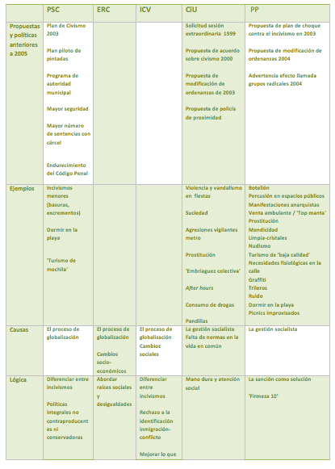
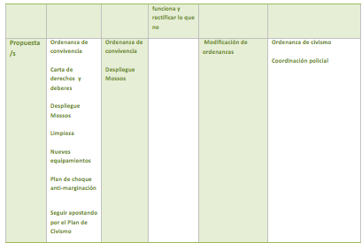
Table 1. Definitions of incivility and political initiatives, by party

The table shows how it is the Conservative Nationalists (CiU) that seemed to take the policy lead when dealing with civility. They articulated the lack of civility as a problem as early as 1999, and just when the Socialists came up with an education-based Plan de Civismo, their proposal was for a new Ordinance. While sharing a significant part of the Nationalists' analysis and suggestions, the Conservatives (PP) only articulated an Ordinance-based policy alternative in 2004, even if they were the first to turn the demand for civility into a condemnation of incivility. Interestingly enough, the Left-wing Nationalists (ERC) and Former Communists refused to engage in the debate. The refusal on the part of the PSC leadership to develop a new bylaw could be understood as a soft alternative to the conservative-led Law and Order approach. However, we would argue that the use of the idea of “authority”, a defense of a penal solution to incivilities and the actual suggestion (quite unusual for a local authority) to toughen the Spanish Criminal Code would at least suggest a surprisingly similar stance on the role of the State to that of the Conservatives. This embracing of an approach to crime and deviance more in tune with the “emergency culture” (Bergalli, 1988) of the 70s and the US-imported punitive populist policies, and thus, as some have argued, would put the Barcelona Socialist leadership in line with political tendencies in other European States, such as New Labor in the United Kingdom (Matthews and Young, 2003).

As for the causes of the proliferation of incivility, we find two competing narratives. One that attributes the social changes linked to its proliferation to the “globalisation process” and one that, in a classic opposition position, blames the problem on the government. Two details stand out, however: first, the Conservative Nationalists' (CiU) reference to the “lack of norms” in society, which reminds us of the arguments laid out by Camps and Giner in 1998; and second, the emphasis on the social (ERC) and social and economic (ICV) consequences of the globalization process. Interestingly enough, all parties seemed to validate the idea that incivilities were a problem, and that they were linked to recent social changes.

7. Running against the clock: Autumn 2005

The combination of the clashes during the Festes, the media pressure and the internal crisis of the governing party crystallized at a Consell Municipal Extraordinari, held on September 6th, which proved to be a point of no return.

Five weeks after the debate, on October 17, 2005, the proposal of a proposal of agreement to approve the normative project of an Ordenanza de medidas para fomentar y garantizar la convivencia en Barcelona was discussed at the Comisión de Gobierno, thus launching the public debate. On the day after, the Comisión approved the preliminary draft and sent it to all the political forces, thus opening the 15-day due period to present amendments and comments.

One day before the closing date, the Dirección de Servicios Jurídicos presented a report on the draft proposal, explaining the methodology used since June 2005 by the team in charge of drawing up the text and the legal logic of the proposition.

As for the methodology, the report stated that

”El anteproyecto ha sido elaborado por una comisión técnica integrada por seis juristas y coordinada por la Dirección de Servicios Jurídicos”, constituida “por primera vez en el mes de junio. Inicialmente la integró u equipo muy reducido de juristas de la Dirección de Servicios Jurídicos. Una vez constituida esta Comisión, acomete una amplia investigación documental sobre la problemática de la convivencia ciudadana.” (...) “En julio se incorporan a la Comisión Técnica dos asesores externos, Luís María Díaz-Picazo Giménez, Catedrático de Derecho constitucional, y Ramón García Albero, catedrático de Derecho penal.”

Their work had consisted of an “amplia investigación documental sobre la problemática de la convivencia ciudadana”, which had produced a report comparing “la regulación de estas problemáticas” from a legal perspective in Germany, France, Italy, United Kingdom and Switzerland; as well as a compilation of similar already-existing Ordinances in Catalonia and Spain; a report on the existing Ordinances at the local level, and a paper on relevant European law.

The draft Ordinance, consisting of 97 articles, was structured around Titles, Chapters and Sections, where each chapter included segments on the “Regulatory fundamentals”, the “Norms of conduct”, a “Sanction regime” and list of “Specific interventions”. Twelve practices understood as threatening to civic city life were identified: “atentados contra la dignidad de las personas”, “grafitos, pintadas y otras expresiones gráficas, así como la colocación de pancartas, folletos y octavillas”, “juegos”, “ocupación del espacio público por conductas relacionadas con la mendicidad”, “oferta y demanda de servicios sexuales en el espacio público”, “realización de necesidades fisiológicas en el espacio público”, “consumo de bebidas alcohólicas”, “comercio ambulante no autorizado”, “realización de actividades y la prestación de servicios no autorizados”, “uso impropio del espacio público”, “actitudes vandálicas en el uso del mobiliario urbano” and “otras conductas”, in order to guarantee the “salubridad pública”, a rational and ordered use of public space, the “protección de la calidad del paisaje urbano”, “la tranquilidad y seguridad de los usuarios y los bienes de la via pública”, the protection of “los menores” and “la propiedad industrial e intelectual y del consumidor”, as well as ensure the “derecho a disfrutar de un espacio público limpio y no degradado”, the “derecho al descanso y a la tranquilidad”, and the right to not be “perturbado en el ejercicio de la libertad de circulación”, among other things.

The aim of the Ordinance was to “hacer frente a aquellos problemas más graves que, por su carácter novedoso, no estaban hasta ahora recogidos en los textos normativos vigentes (como la prostitución o la mendicidad)” and “actualizar aquellas regulaciones que necesitan objetivamente ser aceptadas a fin de que la autoridad local pueda ser ejercitada de forma eficaz y eficiente para reaccionar ante conductas antijurídicas que requieren una nueva tipificación”. It stated that the need for such regulation emerged from “una serie de transformaciones de lo que era el entorno tradicional [de la ciudad]”: “determinados cambios en la forma de concebir lo que es público como espacio que en ocasiones se ocupa de forma intensiva y desproporcionada; el relajamiento de ciertos valores producto de unos déficits educativos tanto en el entorno familiar como en la propia escuela; la pérdida relativa de la conciencia de los que representa en positivo la ciudadanía o la pertenencia a una comunidad; la fuerte presencia de personas que vienen a visitar la ciudad (…), la creciente importancia del fenómeno migratorio; la aprición de fenómenos organizados a través de redes de mendicidad (…) y, en fin, muchos otros fenómenos ligados a los anteriores que también coadjuvan en la percepción de que el espacio público necesita ser regulado a fin de que cumpla su papel contral como centro de convivencia de una sociedad plural.”

One of the striking things about this initial draft is how close it is to the logic, definition and proposals expressed by the PP during the debate in the months before the actual proposal was drafted, as well as the understanding of incivility put forward by the Conservatives since the early 00s (Table 1). The draft included not only illegal practices, but also “anti-legal” activities, and while the introduction to the Ordinance did stress some of the nuances between the Conservative and the Socialist logic, in the detail of the implementation this nuances were lost, and a sanction-oriented rationale prevailed. The analysis of the social ills to be combated, moreover, was a departure from the public opinions expressed by the Socialist leadership until then. This could be explained by the urgency of the drawing-up process, highlighted by several participants in the process, and which would explain an unusual protagonism of the team of experts in charge of framing the draft, and thus a proposal closer to those actors and not their political counterparts.

The day after the report on the draft proposal was presented, the amendment period came to an end. The Conservative Nationalists (CiU) where the only ones who presented an alternative text and openly complained about the process, defining it as “equivocado” and “irresponsable” due to the inability of the three-party coalition to come up with a common text. Their proposal wanted to subject the new Ordinance to a logic of “prevención, intervención, inspección y sanción”, and to complement the disciplinary measures and fines with “medidas sociales que permitan dar salida a la situación actual”.

“No debemos definir por ordenanza como fomentaremos la convivencia y el civismo, sino que debemos dotarnos de herramientas para asegurar esta convivencia, y dotarnos paralelamente de políticas sociales potentes para atacar las causas de algunos de los problemas.”

They suggested using fines as a last resort, especially for offenses related to begging, prostitution, drug-use and using public facilities for personal hygiene. CiU also wanted to publicly declare that all revenues generated by the new bylaw would go to social programs, and suggested commuting the harshest disciplinary measures for services to the community whenever possible, as well as increasing the presence of the Council on the streets, not just with more police, but also by creating “Agentes Cívicos”.

CiU's alternative text was rejected, and the first amended Ordinance, presented on November 9th, only included some of the Conservative Nationalists' suggestions by adding a few remarks about the special needs of older and disabled people. The other parties with political representation presented only specific amendments, which show different approaches to the problem.

ICV tried to eliminate from the Ordinance those behaviors understood to have social roots (non-organized begging, prostitution, alcohol consumption when not causing problems to other parties, etc.), and questioned the idea that migrants could be “rewarded” for collaborating with the authorities on issues related to the Ordinance. They also rejected the proposal to demand that the organizers of political and social activities in public space would need to show proof of insurance in order to be able to hold events, showed reluctance to accept an increase in Police powers and called for the Consejo de Ciudad, a participatory body, to take an increased protagonism in monitoring the implementation of the Ordinance.

The PP, on the other hand, tried to include a more straightforward reference to the role of migrants by demanding that their “civility” was reflected in police reports and could limit access to public services; emphasized the need for the text to cover not just public property, but also private assets; suggested establishing mechanisms to ensure the implementation of the civility regulation and generally increasing the disciplinary capabilities of the police, especially when dealing with prostitutes, beggars, street vendors and minors. Finally, the Conservatives insisted on the need to increase the role of the Police when dealing and mediating with social problems and conflict.

The Left-wing Nationalists (ERC), in turn, emphasized the need to limit the ambiguity of some of the chapters in order to avoid discretionality in the implementation of the norm. They also defended the need not to stigmatize certain social groups, suggested lowering the amounts of the fines and defended removing the need for social organizations to provide insurance for activities organized in public space. Finally, their amendments highlighted the need to avoid any violation of Constitutional rights (such as Presumption of Innocence and Equality before the Law) and favored a commitment to mediation as a mechanism to deal with conflict in public space.

The picture that emerges from these contributions and amendments in relation to the most crucial approaches can be classified and summarized as follows:

- Role of the police
More protagonism/social mediation___________________________Police duties only
PP ICV
CiU PSC ERC

- Social problems (begging, prostitution)
Police approach___________________________________________ Social approach
PP CiU ICV
PSC ERC

- Role of migrants in relation to incivilities
Responsible_______________________________________________Not responsible
PP CiU ICV
PSC ERC

- Respect for collective rights
No_______________________________________________________________ Yes
PSC CIU ICV ERC PP

In spite of the debate, most suggestions were not included in the subsequent versions of the text, which was finally made public on November 10th. This was not yet the final version, however, as the Town Hall regulations included the need to subject the proposal to a 30-day public information period for ordinary people and groups to make amendments. In those 30 days, the proposal was also sent to the Consejos de Distrito, and an extraordinary session of the Consell de Ciutat (“máximo órgano consultivo y de participación del Ayuntamiento de Barcelona”) and an Audiencia Pública were sheduled.

The Audiencia Pública, held on December 12, five days before the closing date for the information and amendment period, was the only non-representative space for direct participation in the whole policy process of the Ordinance. The tension that reigned in the hours it lasted, as well as the conflicting views expressed by those who asked to speak show what a heated debate the process had provoked. Out of the 49 contributions, 33 people spoke against the proposal or were critical of it, 14 defended it and 2 people expressed doubts without taking a clear stand (Figure 3).

Figure 3: opinions expressed during Audiencia Pública

During the information period, 35 organizations and individuals presented written comments to the proposed Ordinance, and they all received a personalized response from the Council, which allows us to extend our analysis not only to the motives of those who chose to try to participate in the process, but also to measure the degree of permeability to outside suggestions of those in charge of the final version of the bylaw the Dirección de Servicios Jurídicos.

Of the 35 comments submitted (not including those of the political parties, which also used this second round to pursue their goals), most can be attributed to community and social organizations; groups of people personally affected by the proposed Ordinance (sex workers, skaters, pub owners) and corporate or small-business lobbies (Table 2).

Community organizations | Personally affected | Corporate lobbies
Entitats d'Hostafrancs i la Bordeta  CCOO del Barcelonès  Unio de Consumidors de Catalunya  Plataforma veinal i de comerciants de Barcelona  AAVV de Poblenou  FAVB  AAVV Vila Olimpica  Comite d'empresa de l'Ajuntament de Barcelona  Plataforma d'entitats juridiques  Salvem al maradona de la rambla  SOS Racisme  Comite Primer de Desembre  Observatori del Sistema Penal  Plataforma l'ave pel litoral  Consell Escolar  Huelga mundial de mujeres | Associació defensa del dret a la nuesa  Altarriba, amigos de los animales  Transexuals de catalunya  Patinadors rodats de barcelona  Plataforma a favor d'una prostitucio reglada  Patinadors de barcelona  Comite català de representants de minusvalids  Treball sexual i convivencia | Venedors de vehicles a motor  Gremi de restauració de Barcelona  Cambra de comerç  Cambra of de comerç, industria i navegacio  Federació catalana de locals d'oci nocturn  Turisme de barcelona  Consell de gremis  Autoritat portuaria de barcelona  Barcelona shopping line  Gremi d'empresaris de cinemes de Catalunya

Table 2. Groups and organizations that presented comments during the information period.

Most groups in columns 1 and 2 suggested either the withdrawal of certain chapters or of the whole Ordinance altogether, while others tried to include specific problems that had not been taken into account. The corporate lobbies, in turn, tended to praise the text and proposed broadening its scope or toughen the disciplinary measures.

Out of the 334 comments that were presented, the Dirección de Servicios Jurídicos fully incorporated 7 and partially incorporated 15. 212, thus, were rejected (Figure 4). However incomplete a quantitative explanation of the data can be, it does seem worth highlighting that the 7 accepted comments came from the Autoritat Portuaria, the Consejo de Gremios, the Cámara de Comercio and the Unión de Consumidores de Catalunya. Out of the final comments submitted by the political parties, 11 were fully accepted, 6 were partially accepted and 135 were dismissed (25 if we exclude the comments re-submitted by the PP) (Figure 5).

Figure 4: Percentage of civil society comments accepted, partially accepted and rejected.
Figure 5: Percentage of party comments accepted, partially accepted and rejected.

Overall, the picture that emerges from the participatory process is that of a rushed process, as both several of the actors involved and certain details of the policy process confirm. This might have been due to the media pressure and the situation of internal crisis borne by the governing party. However, none of this seems to be able to fully account for the fact that the final text does not reflect the ideas of the Socialist Party as they were expressed in the year before the passing of the Ordinance, nor for the resilience of the policy process when faced with external criticism and comments.

8. Concluding remarks

There are several lessons to be drawn from the political process of Barcelona’s Civility Ordinance. We will highlight those related to security as local public policy, on the one hand, and the above-mentioned defining up of deviance.

As for the policy cycle of civility in the case of Barcelona, the field work shows that when talking about security policy, we are dealing with closed processes and limited policy communities, opened only to formal processes and reluctant to being accountable. One could argue that this resilience to include a diverse range of actors could be a trait specific to security public policy in general, but we would be reluctant to turn this hypothesis into a fact due to the “noise” introduced in the policy process of the Civility Ordinance by the characteristics of the policy window that opened up in 2005 and made the policy possible (precipitation, internal crisis, media pressure). The Civility Ordinance, thus, should be studied in light of other comparable security policies before concluding that there is something specific about such policies that makes them especially reluctant to the opening-up of policy communities, transparency and accountability.

Moreover, while looking at the policy cycle of the Civility Ordinance on its own, as the product of a set of local circumstances and power games, can be useful and shed some light on how decisions are made in the wannabe global city, it is necessarily a limited approach. In a globalized world, local processes fail to explain those factors not linked to the nearby reality and debates. In 2005, Barcelona was dealing with very specific problems, linked to recent and not-so-recent developments, and it would be possible to come up with a local narrative to explain, on its own, why the city opted for the defining up of civility. But the resulting picture would, no doubt, be misleading. The need for a new consensus around civility related to a post-dictatorial history forgets to explain why Barcelona was debating incivility on the same year that Tony Blair was presenting New Labour’s “Respect agenda”, for instance, and when the whole continent was beginning to broaden the definition of deviant and improper behavior in public space and establishing disciplinary measures for offenders (European Commission 1998; Urban Task Force 1999). The invisible –but very present- actor in the policy cycle of Barcelona’s civility debate was a global dynamic to punish difference and ignore bottom-up, participatory dynamics using Security as an excuse; a global dynamic that seems to be managing to take advantage of locally-generated windows of opportunity to impose what Klein (2007) has called a shock doctrine, paralyzing rights-based approaches and articulating a security hyperbole where Law and Order is the only alternative in the face of the uncertainty of life in diverse environments.

The study of local policy processes, thus, needs to incorporate the European/global dimension and tackle the mechanisms through which the security hyperbole is gaining ground in the world’s political agenda. In this context, the dissection of local policy processes can only be the fundamental basis of this comparative endeavor, which should be able to shed light on key issues related to urban policy, such as:

- How is the relationship between Security and the management of diversity (Jackson 1998, Bauman 1997), and public policy in general (Harvey 2001, Davis 1991, Smith 1996), being articulated.
- How is the urban malaise (Fischer 1973) and the idea that recent economic, social and cultural changes have not yet been assimilated –and might never be-, as well as the generalized feeling of loss of a homogeneous, cohesionated and caring past is contributing to reinforce the need to secure public space to defend us from a threatening them (Kessler 2009, Bauman 1997, Sennett 1977).
- What are the policy and social implication of the blurring of the boundaries between Homeland Security and Community Safety for urban policy.
- What is the underlying narrative underneath different aspects of urban security policy, such as the proliferation of surveillance (Fyfe and Banniester 1998, Painter and Tilley 1999), the defining up of deviance and the fencing out or downright privatization of public spaces (Kayden 2000).
- How is the preventive turn and the implementation of the Broken Windows (Kelling and Coles 1996) logic to all aspects of public policy affecting urban policy in general.

References

- Books

Bauman, Z. (1997) Postmodernity and its Discontents. Cambridge: Polity Press.

Bauman, Z. (2000) Liquid Modernity. Cambridge: Polity Press.

Beck, U. (1992) Risk Society: Towards a New Modernity. London: SAGE.

Blanco, I. (2004) Governance urbana i polítiques d’inclusió sòcio-espacial. UAB: Unpublished dissertation.

Cobb, R.W. y Elder, C.D. (1983) Participation in American Politics: The Dynamics of Agenda-building. Johns Hopkins University Press, Baltimore, M.D. First published in 1972

Davis, M. (1991) City of Quartz. London: Verso.

Dowding, K. (1996) Power. Minneapolis: University of Minessota Press.

Fairclough, N. (2000) New Labour, New Language? London: Routledge.

Fischer, C. (1973) Urban Malaise. Berkeley: University of California.

Fyfe, R. (ed) (1998) Images of the Street: Planning, identity and control in public space. New York: Routledge.

Garland, D. (2001) The Culture of Control. Crime and Social Order in Contemporary Society. Chicago: The University of Chicago Press.

Harvey, D. (2001) Spaces of Capital. New York: Routledge.

Harvey, D. (1973) Social Justice and the City. Baltimore: Johns Hopkins University Press.

Hill, M. (2005) The public policy process. Essex: Pearson Education.

Huertas Clavería (2006) Una història de ‘La Vanguardia’. Barcelona: Angle Editorial.

Imrie, R. and Raco, M. (2003) Urban Renaissance? New Labour, community, and urban policy. Bristol: Policy Press.

Jacobs, J. (1961) Death and Life of Great American Cities. New York: Vintage Books.

Kelling, G. And Coles, M. (1996) Fixing Broken Windows: restoring Order and Reducing Crime in Our Communities. London: Martin Kessler Books.

Kessler, G. (2009) El sentimiento de inseguridad. Sociología del temor al delito. Buenos Aires: Siglo XXI.

Kingdon, J. (2003) Agendas, alternatives and public policies. New York: Touchstone.

Klein, N. (2007) The Shock Doctrine: The Rise of Disaster Capitalism. Canada: Knopf.

Lasswell, H. (1996) El estudio de las políticas públicas. México: Porrúa.

Lefevre, H. (1974) La production de l’espace. Paris: Anthropos.

Low, S. And Smith, N. (eds) (2006) The Politics of Public Space. New York: Routledge.

Matthews, R. and Young, J. (2003) The New Politics of Crime and Punishment. Devon: Willan Publishing.

Peres Neto, L. (2010) Prensa, política criminal y opinión pública: el populismo punitivo en España. Unpublished dissertation.

Rose, R. (2006) Participation in Civil Society. Dublin: European Foundation for the
Improvement of Living and Working Conditions.

Sassen, S. (2001) The Global City. Princeton: Princeton University Press.

Sennet, R. (1977) The Fall of the Public Man. New York: Knopf.

Smith, N. (1996) The New Urban Frontier: Gentrification and the Revanchist City. New York: Routledge.

Sorkin, M. (ed) (1992) Variations on a Theme Park: The new american city and the end of public space. New York: Hill and Wang.

Stone, C.N. (1989) Regime Politics. Kansas: University Press of Kansas

Wacquant, L. (1999) Les prisons de la misère. Paris: Raisons d'Agir.

Waicquant, L. (2009) Punishing the Poor. The Neoliberal Government of Social Insecurity. Durham: Duke University Press.

- Academic papers

Bannister, J., Fyfe, N. And Kearns, A. (2006) “Respectable or Respectful? (In)civility and the City”, Urban Studies, 43(5-6): 919-937.

Boyd, R. (2006) “The Value of Civility?”, Urban Studies, 43: 863-878.

Coleman, R. and Sim, J. (2000) “You’ll Never Walk Alone: CCTV surveillance, order and neolioberal rule in Liverpool city centre, British Journal of Sociology, 51: 623-639.

Crawford, A. (2006) “Fixing Broken Promises? Neighbourhood Wardens and Social Capital”, Urban Studies, 43: 957-976.

Dowding, K. et al. (1999) “Regime Politics in London Local Government”, Urban Affairs Review, 34: 515-545.

Flint, J. and Nixon, J. (2006) “Governing Neighbours: Anti-Social Behaviour Orders and New Forms of Regulating Conduct in the UK”, Urban Studies, 43: 939-955.

Fyfe, N. Bannister, J. And Kearns, A. (2006) “(In)civility and the City”, Urban Studies, 43(5-6): 853-861.

Helms, G. (2007) “Municipal Policing Meets the New Deal: The Politics of a City-Centre Warden Project”, European Urban and Regional Studies, 14(4): 290 - 304.

Ismaili, K. (2006) “Contextualizing the Criminal Justice Policy-Making Process”, Criminal Justice Policy Review, 17: 255-269.

Lieberg, M. (1995) “Teenagers and Public space”, Communication Research, 22: 720-746.

Malone, K. (2002) “Street Life: Youth, Culture and competing uses of Public Space”, Environment and Urbanization, 14: 157-170.

Mooney, J. and Youg, J. (2006) The decline in crime and the rise of anti-social behaviour. Probation Journal, 53: 397-407.

Palacios, N. (2001). “Una mirada al conflicto. Temas de mediación, sección de fundamentos conceptuales”. http://www.mediazion.fr.st/

Raco, M. (2007) “Securing Sustainable Communities: Citizenship, Safety and Sustainability in the New Urban Planning”, European Urban and Regional Studies, 14(4): 305 - 320.

Sampson, R. and Raudenbush, S. (1999) “Systematic Social Observation of Public Spaces: A New Look at Disorder in Urban Neighborhoods”, The American Journal of Sociology, 105(3): 603-651.

Siebel, W. (2006) “Security and the urban public sphere”, German Policy Studies, 3(2): 19-46.

Smithsimon, G. (2008) “Dispersing the Crowd: Bonus Plazas and the Creation of Public Space”, Urban Affairs Review, 43: 325-351.

Van Brunschot, E. (2007) “Securing the Urban Environment: Bylaws and Ordinances”, Paper presented at the annual meeting of the American Society of Criminology, Atlanta Marriott Marquis, Atlanta, Georgia.

Wagenaar, H. (2007) “Governance, Complexity and Democratic Participation: How Citizens and Public Officials harness the Complexities of Neighbourhood Decline”, The American Review of Public Administration, 37: 17-50.

Young, J. (2005) Moral Panics, Margate and Mary Poppins: Mysterious happenings in south coast seaside towns. Crime, Media, Culture vol 1(1): 100-105.

- Book chapters

Jackson, P. (1998) “Domesticating the Street: Planning, Identity and Control in Public Space”. ”. In Images of the Street: Planning, identity and control in public space, edited by Fyfe, N., 176-191. New York: Routledge.

Katz, C. (2005) “Power, Space and Terror: Social reproduction and the Public Environment”. In The Politics of Public Space, edited by Low, S. And Smith, N., 105-122. New York: Routledge.

- Reports and official documents

Ayuntamiento de Barcelona (2006) Archivo administrativo de la Ordenanza de medidas para fomentar el civismo y la convivencia en el espacio público de Barcelona. Documento interno.

European Commission (1998) Response of the Expert Group on the Urban Environment to the Communication “Towards an Urban Agenda in the European Union”. Brussels: EC.

Urban Task Force (1999) Towards an urban renaissance : final report of the Urban Task Force. London: Eldon House.

Wood, M. (2004) Perceptions and experience of anti-social behaviour: findings from the 2003/2004 British Crime Survey. Online Report 49/04. London: Home Office.

Security, Technology and Society, Department of Sociology, Universitat de Barcelona.
Its formal name is Ordenanza de medidas para fomentar y garantizar la convivencia ciudadana en la ciudad de Barcelona [Ordinance of measures to promote and guarantee peaceful coexistence in the city of Barcelona]. Available al http://w3.bcn.es/fitxers/ajuntament/bop20a12006.410.pdf (Accessed on June 11, 2013).
Excerp from “Exposición de motivos”.
In 2005, only Valladolid had passed a similar bylaw.
Ranulf, S. (1964) Moral Indignation and Middle Class Psychology. New Yeork; Schoken Books, as cited in Young 2005.
'Q&A: Respect agenda', BBC News, 11/01/2006.
'Italy: A proliferation of forbidden behaviour', Statewatch News Online, 01/2009.
Moynihan, D.P. (1993) “Defining Deviancy Down”, The American Spectator, vol 62(1): 19-30.
Camps, V.; Giner, S. (1998) Manual de civisme. Barcelona: Editorial Ariel.
Interview, 12/01/10
Made up of members of the three parties in power. Interview, 12/01/10.
Which would result in a book, Subirats, M. et al. (2006) Civisme per la convivencia. Barcelona: Icària
Which, in the end, only met once during lunch, as confirmed by several participants.
Interview, 15/12/09.
Interview, 12/01/10.
Interview, 26/01/10.
“Clos admet "preocupació" pel "deteriorament del civisme" a Barcelona i demana més recursos jurídics i un "pacte social", Europa Press, 03/09/03.
Interview, 15/01/10.
Interview, 15/01/10; interview, 21/01/10; interview, 26/01/05.
‘Alberto Fernández teme que haya nuevos altercados violentos durante la Mercè’, LV, 01/09/05
“Mascarell diu que el ‘turisme de motxilla’ perjudica la ciutat i anuncia que dormir al carrer será sancionat”. Vilaweb, 25/08/05.
‘Impotencia municipal’, LV, 25/08/05.
‘El pleno extraordinario de Barcelona sobre incivismo se celebrará el martes’, LV, 01/09/05.
Consell Municipal Extraordinari. Minutes: 3, 6/9/2005.
Table drawn up using the minutes of the Consell Municipal Extraordinari held on September 6th, 2005 (Administrative file: 1-29), the press coverage of the process and other public interventions of the relevant actors.
Administrative file: 105-106.
El Prat de Llobregat, L'Hospitalet de Llobregat, Mataró, Roda de Ter, Tarragona and Viladencans.
Valladolid.
Even if the positions expressed at the Plenary and in the amendments were sometimes contradictory or not entirely coherent, as is the case with ERC's proposals.
The PP chose to re-submit all the comments that had already been presented during the first round of amendments. Including them in the final count alters the results, and we've chosen to leave the out to present a picture which we think fits the process better.

